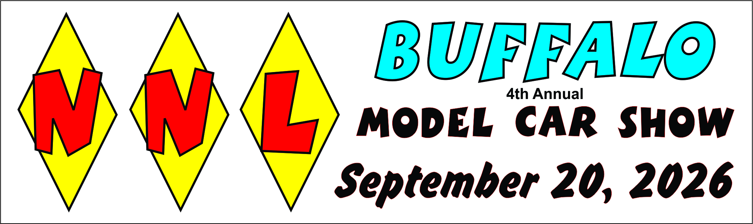
NNL Buffalo Model Car Show Sponsor / Vendor Table
Request Form
www.nnlbuffalo.com
Online Registration Available
Dear Friends,
We are excited to announce that the NNL Buffalo Model Car Show will be taking place on September 20, 2026—our fourth annual event in Western New York. NNL Model Car Shows are held across the country each year, and this year’s show promises to be an outstanding experience.
This event will be Non-Competitive and will feature both People’s Choice and Builder’s Choice Awards. The winners of each Best of Category will receive one award for Builder's Choice and one for People's Choice. By making a donation of $50.00, you will sponsor two of these prestigious awards. Additionally, the Theme Awards and Best of Show will be all-inclusive of the entries, with one award given for each. The Best of Show award will be valued at $75.00.
Here’s how you can contribute:
- $25.00 – Become a General Support Sponsor this gets your name featured on our website.
- $50.00 – Receive an ad on both our website and in the printed brochure distributed on the day of the show.
- $75.00 – Sponsor the Best of Show award and enjoy an ad on our website, plus a spot in the printed brochure handed out during the event.

Your support helps make this event possible, and we greatly appreciate your consideration. We hope to see you there!

Best of Categories
- Best Paint  - Best Engine  - Best Custom  - Best Automotive Diorama.  - Best Motorcycle | - Best primer (Work in progress)  - Best Military Non Tracked including Dioramas  - Best Commercial  - Best Junior 16 and Younger

Special Awards
ALL Age Groups Included
- Best Theme ” Hot Wheels”
- Best Sub Theme “Year Ending in 6”
- Best in Show

General Information
Organization/Name: Required _____________________________________________________
Address: Required ______________________________________________________________
______________________________________________________________________________
Phone: Required ________________________Email: Required ___________________________
Web Address: Optional ______________________________________________
Sponsorship Information, Please contact Frank Blonski at nnlbuffalo@gmail.com 716-867-2244 or Website for availability.
Best of Show Sponsor: _______ x $75.00 = ___________
Best of Award Sponsor: ______ x $50.00 = ____________ Awards Choice __________________ Awards 2nd Choice __________________
Theme Award Sponsor: ______ x $50.00 = ____________ Awards Choice __________________ Awards 2nd Choice __________________
General Support Sponsor: ____ x $25.00 = ____________
Total: ____________ Payable to: Francis Blonski
Payments can be made via PayPal to: frankie@fabresinworks.com
Checks can be sent Payable to: Francis Blonski PO Box 258 Getzville New York 14068 Attn: NNL Buffalo MCS

Vendor Table Information

$30.00 for the first table; $50.00 / for 2 tables; $70.00 / 3 tables; $90 / for 4 tables; $110 / for 5 tables; $130 / for 6 tables. Limit 6 Tables per Vendor. Each vendor is asked to donate an item for the kit raffle. 2 people per vendor. Additional people must pay General Admission.
Please list any special requirements for tables like power, against the wall etc.
Please list Names of additional people:

Number of Tables Required _______ = ________
Plus Total from above if Sponsoring + _________
Grand Total = _________ Payable to: Francis Blonski
A receipt will be issued when payment is received. Please include your email address to receive a receipt. Your receipt is your proof of payment. If you require an invoice, please email Frank Blonski at NNLBuffalo@gmail.com

