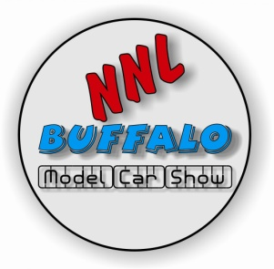 Please fill out this form, and we will assign the registration numbers. PLEASE PRINT CLEARLY.
NNL Buffalo
Registration Form
NAME:
ADDRESS:
CITY:
STATE: | ZIP CODE:
PHONE NUMBER: | EMAIL:
CLUB AFFILIATION (if any)
 | Office Use Only  Reg # | Year | Make | Model | Category #
1.
2.
3.
4.
5.
6.
7.
8.
9.
10

By my signature, I hereby release the Madonna Council #2535, the NNL Buffalo Modelers, its officers, directors, members, agents, employees, and anyone else connected with the management of this event from damages, injuries, losses, judgments, or claims from any cause whatsoever that may occur through participation in this event. Furthermore, in consideration of this entry, I agree to the use of my name and/or photo of myself and/or my vehicle(s) in connection with magazine and internet-based coverage of this event with no further compensation.
NNL Buffalo reserves the final right as to placement of any model based on classes, number, and types of entries within classes.
Signature:__________________________________________________________________Date:______________

